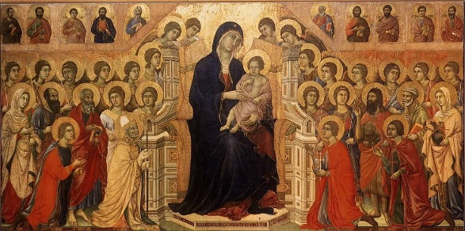
‘A Saint’s Life’ Biography Research Project
In the words of Fr. Barron, the only thing we need desire in life is to be a saint. As we begin this journey, we are going to investigate the lives of Catholic saints. For this project, you will be required to do the following:
- Select one saint’s life to research. Choose a saint that you can find an abundance of information on.
- Locate at least 3 reputable sources to gather information on the life of your chosen saint.
- Read carefully through each article you find.
- Highlight (in one colour) common important facts and events in the life of the saint that are mentioned in all 3 of your sources of information. These are your most important key points.
- Highlight (in another colour) details that support the key points you have identified.
- Record the key important points and details in point form on a piece of paper. It is crucial that you organize this information in a logical sequence for you will need to tell the life of your chosen saint in the order that events in his/her life occurred.
- Record all the information you need to complete a bibliography for this project. Manage your time effectively. Follow these timeline guides:
First 2 weeks: Gather research information
Second 2 weeks: Read all information and make notes
Last 2 weeks: Complete published biography.
- Hand in your draft for approval. Make sure you have included the bibliography of the sources you have used.
- Publish your biography as a picture book using Word or Google docs.

Due Date: Thursday Dec. 19, 2019

